Group #: Mon4pm_Group4

Sujeeth Shetty

Sai Harshavardhan Bachina

Srisha Balaji

Siddharth Hareendran

**SQL-Mongo Project – Spatial Data of US Wildfires**

BUAN 6320

|  |  |  |  |  |
| --- | --- | --- | --- | --- |
| **Activity** | **Sujeeth Shetty** | **Sai Harshavardhan Bachina** | **Srisha Balaji** | **Siddharth Hareendran** |
| Prepared Data Model and Created Physical DB | x | x | x | x |
| Loaded Data into Database | x | x | x | x |
| Wrote SQL Queries |  |  |  |  |
| Prepared Mongo Database |  |  |  |  |
| Loaded data into Mongo DB |  |  |  |  |
| Wrote Mongo Queries |  |  |  |  |
| Prepared Report |  |  |  |  |
| Reviewed Report |  |  |  |  |

Contents

Data Model 5

Assumptions/Notes About Data Entities and Relationships 5

Entity-Relationship Diagram 6

Physical Database 7

Assumptions/Notes About Data Set 7

Screen shot of Physical Database objects 7

Data in the Database 16

SQL Queries 17

Query 1 17

Question 17

Notes/Comments About SQL Query and Results (Include # of Rows in Result) 17

Translation 17

Screen Shot of SQL Query and Results 17

Query 2 18

Question 18

Notes/Comments About SQL Query and Results (Include # of Rows in Result) 18

Translation 18

Screen Shot of SQL Query and Results 18

Query 3 19

Question 19

Notes/Comments About SQL Query and Results (Include # of Rows in Result) 19

Translation 19

Screen Shot of SQL Query and Results 19

Query 4 20

Question 20

Notes/Comments About SQL Query and Results (Include # of Rows in Result) 20

Translation 20

Screen Shot of SQL Query and Results 20

Query 5 21

Question 21

Notes/Comments About SQL Query and Results (Include # of Rows in Result) 21

Translation 21

Screen Shot of SQL Query and Results 21

Query 6 22

Question 22

Notes/Comments About SQL Query and Results (Include # of Rows in Result) 22

Translation 22

Screen Shot of SQL Query and Results 22

Data Review for MongoDB 23

Assumptions/Notes About Data Collections, Attributes and Relationships between Collections 23

Physical Mongo Database 24

Assumptions/Notes About Data Set 24

Screen shot of Physical Database objects (Database, Collections and Attributes) 24

Data in the Database 24

MongoDB Queries/Code 25

Query 1 25

Question 25

Notes/Comments About MongoDB Query/Code and Results (Include # of Documents in Result) 25

Translation 25

Screen Shot of MongoDB Query/Code and Results 25

Query 2 26

Question 26

Notes/Comments About MongoDB Query/Code and Results (Include # of Documents in Result) 26

Translation 26

Screen Shot of MongoDB Query/Code and Results 26

Query 3 27

Question 27

Notes/Comments About MongoDB Query/Code and Results (Include # of Documents in Result) 27

Translation 27

Screen Shot of MongoDB Query/Code and Results 27

Query 4 28

Question 28

Notes/Comments About MongoDB Query/Code and Results (Include # of Documents in Result) 28

Translation 28

Screen Shot of MongoDB Query/Code and Results 28

Query 5 29

Question 29

Notes/Comments About MongoDB Query/Code and Results (Include # of Documents in Result) 29

Translation 29

Screen Shot of MongoDB Query/Code and Results 29

Query 6 30

Question 30

Notes/Comments About MongoDB Query/Code and Results (Include # of Documents in Result) 30

Translation 30

Screen Shot of MongoDB Query/Code and Results 30

# Data Model

## Assumptions/Notes About Data Entities and Relationships

1. Users can enter as many Fire data in the system. Each fire reported is identified by key FOD_ID (Global Unique Identifier)
2. The point location of each fire is unique.
3. FIPS record has Federal Information Process Standards (FIPS) publication of counties and equivalent entities.
4. The Owner information will be maintained in a separate record and will be assigned to the fire reported.
5. The Source record maintains information necessary to track back to the original record and is identified by key FPA_ID
6. The source System Type record maintains the type of source that the record was drawn (federal, nonfederal or interagency)
7. MTBS perimeter dataset has Incident information and can be assigned to the Fire reported by the user.
8. User can assign Incident from the ICS-209 report to the reported fire.
9. The details of agency preparing the fire report, based on code/name in the source dataset is maintained in Source Reporting record.
10. NWCG record has NWCG identifiers for agency units that were active as of 9 January 2017 and will be assign to each fire by the user.
11. The Source table which holds original record information is identified by key FPA_ID and the child record Fire is linked to Source table by the foreign key. Currently there are only three System Types, suppose if the admin decides to add one System Type modifying Source record is bad idea. Hence the System Type is maintained in a separate record and linked between Source table by SOURCE_SYSTEM_TYPE foreign key. So, this model is normalized to 3NF.

## Entity-Relationship Diagram

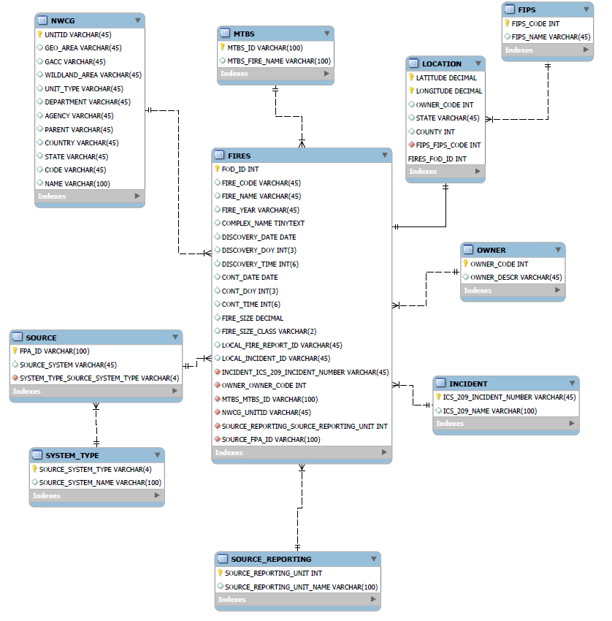

# Physical Database

## Assumptions/Notes About Data Set

1. The NWCG_REPORTING_UNIT_ID field in Fire record had 17 rows of data which were missing from NWCG_UnitIDActive_20170109. To maintain referential integrity, during database normalization, we have removed those rows from FIRES.

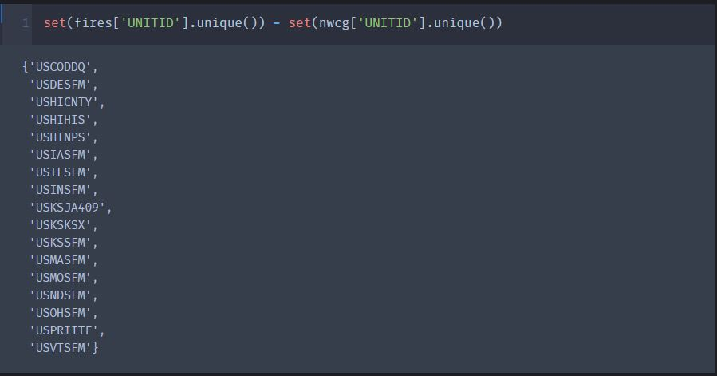

1. The Date fields in original dataset were in Julian Format and has been converted to YYYY-MM-DD

## 

## Screen shot of Physical Database objects

**FIPS Table:**

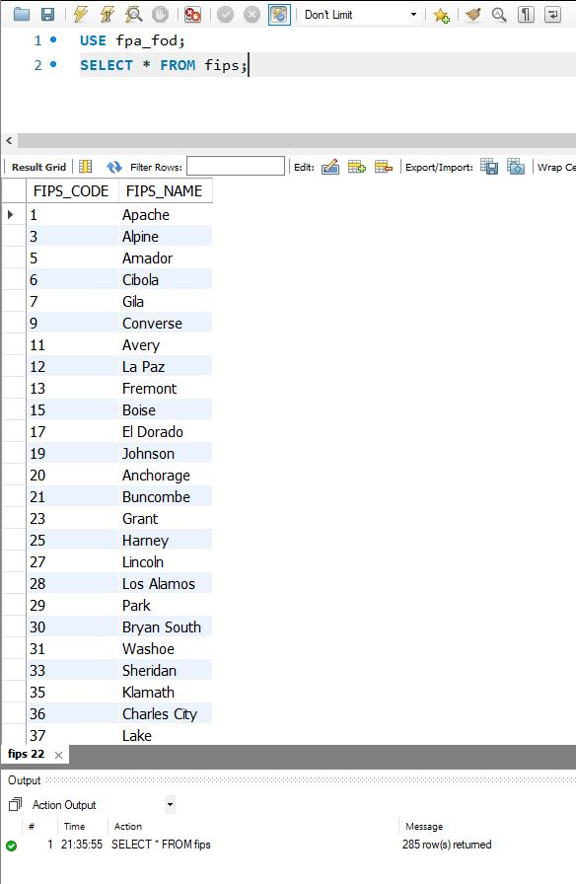

**FIRES Table:**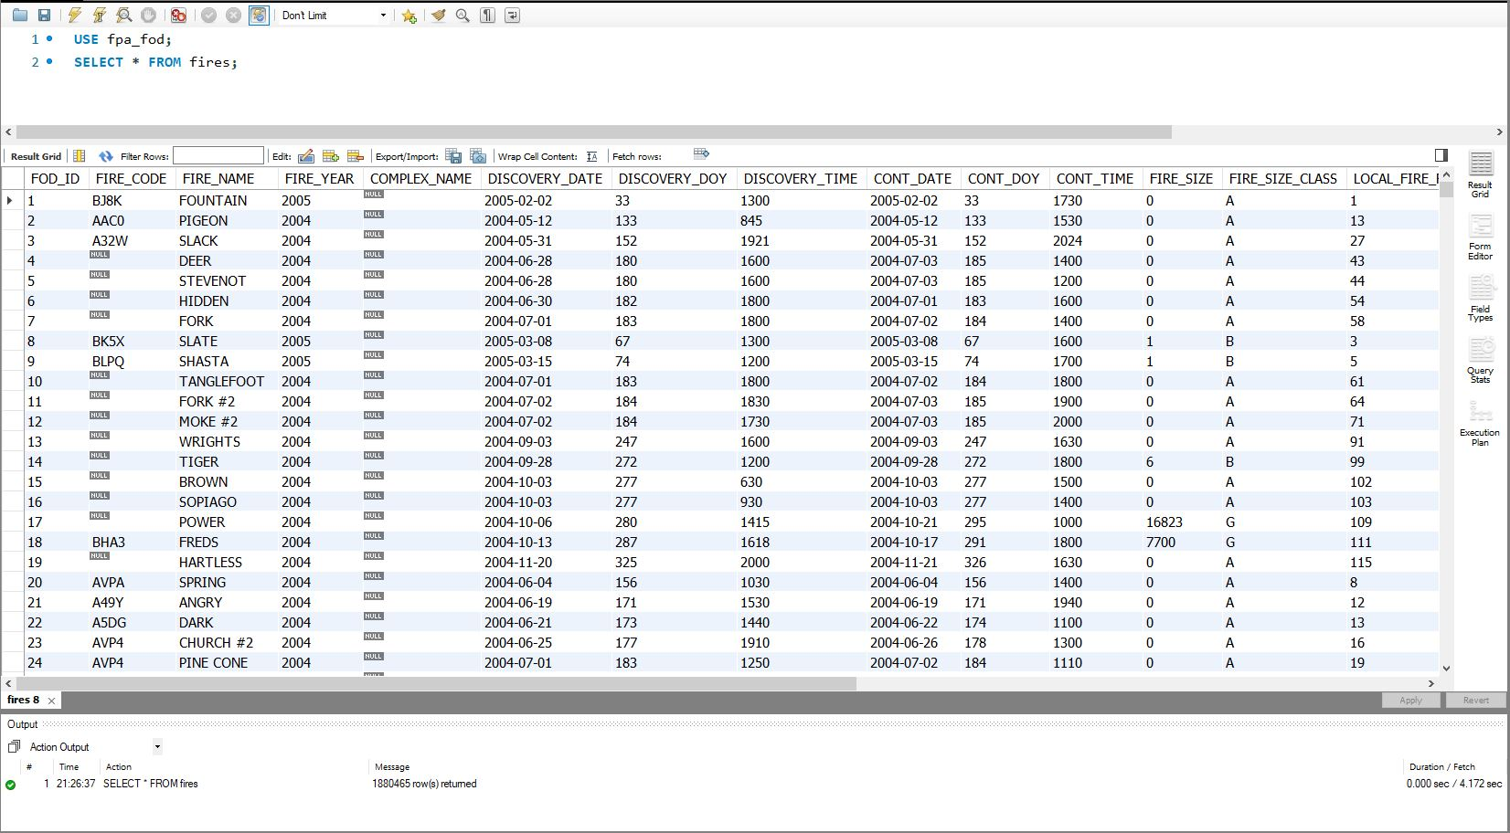

**INCIDENT Table:**

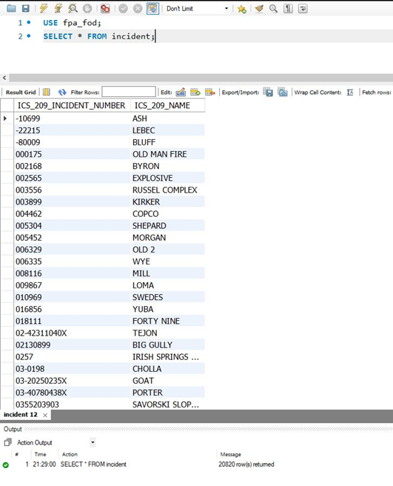

**Location Table:**

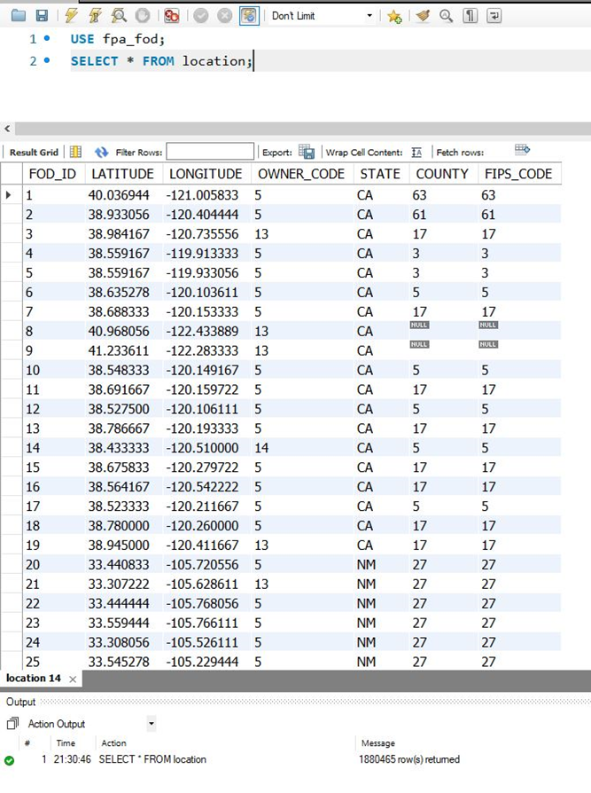

**MTBS Table:**

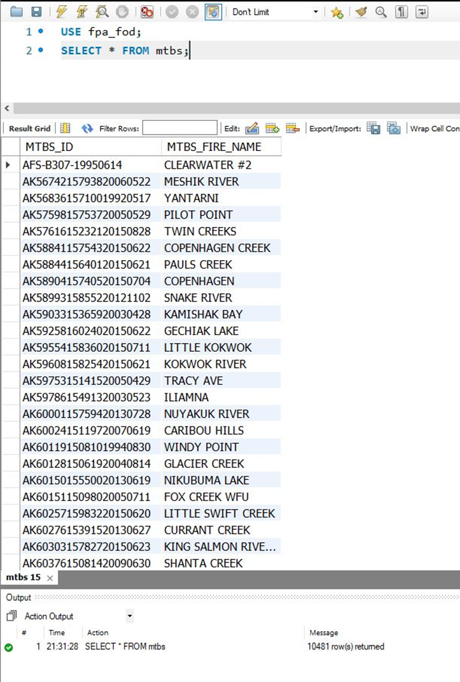

**NWCG Table:**

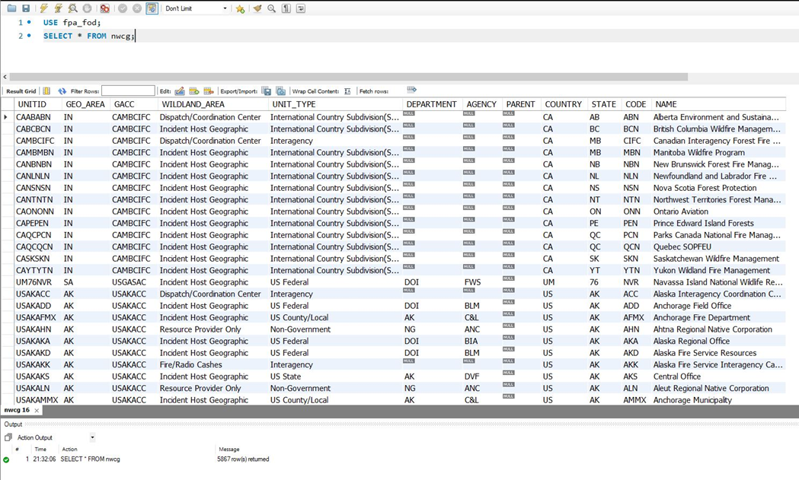

**OWNER Table:**

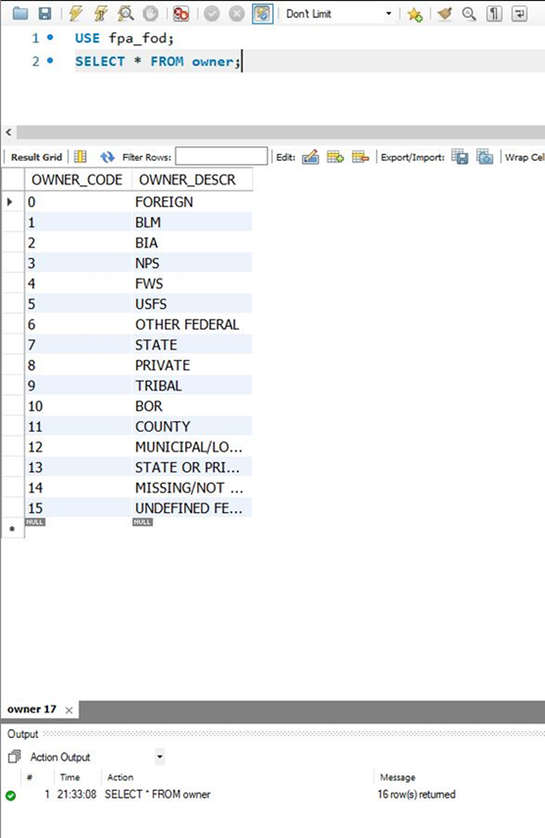

**Source Table:**

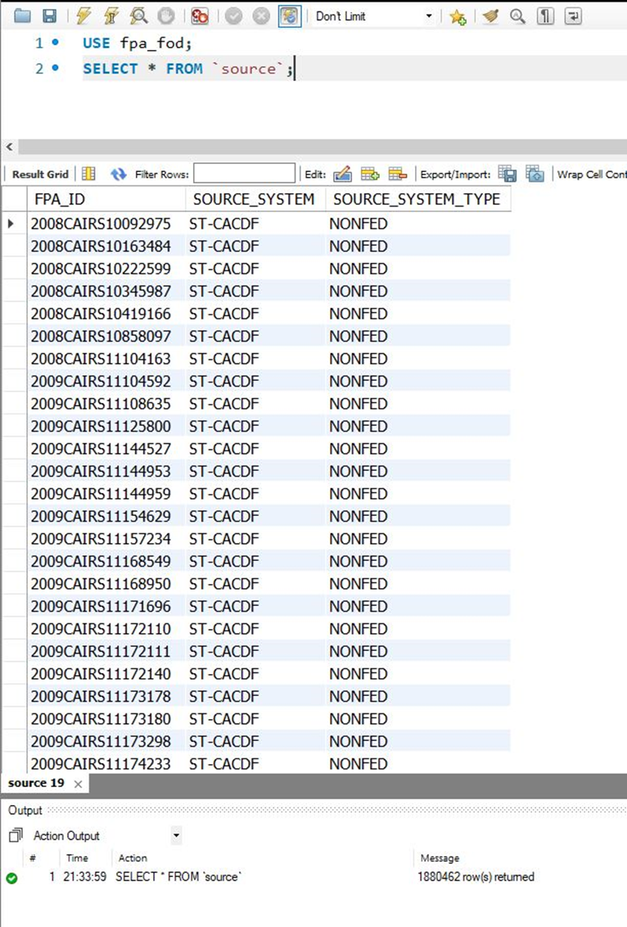

**SOURCE_REPORTING Table:**

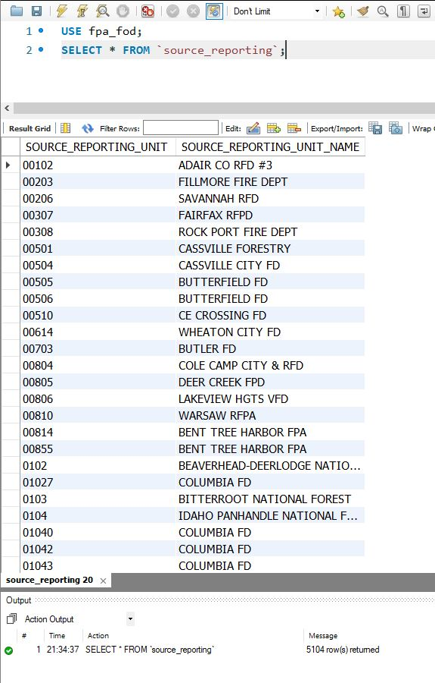

**SYSTEM_TYPE Table:**

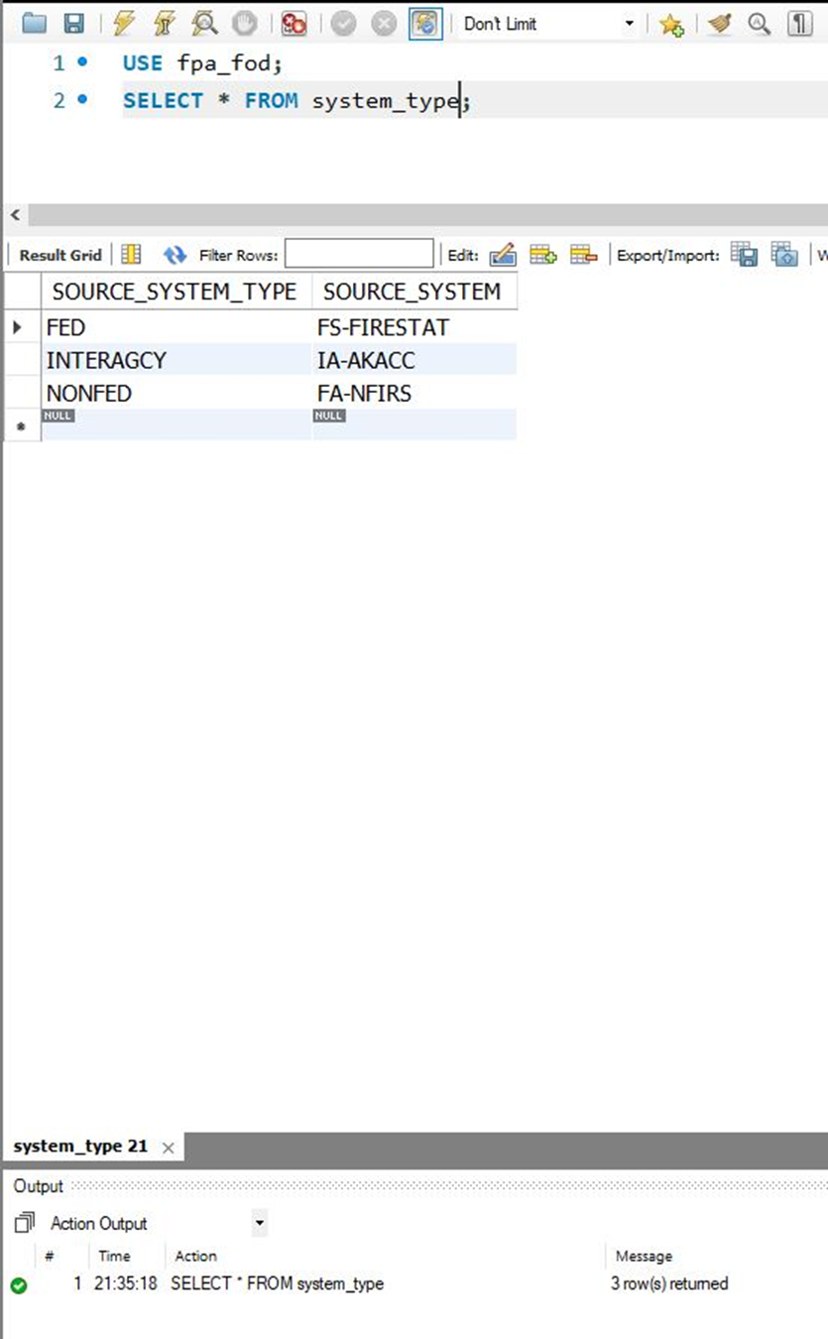

## Data in the Database

|  |  |  |  |
| --- | --- | --- | --- |
| **Table Name** | **Primary Key** | **Foreign Key** | **# of Rows in Table** |
| FIRES | FOD_ID | 1)INCIDENT_ ICS_209_INCIDENT_NUMBER  2)OWNER_OWNER_CODE  3)MTBS_MTBS_ID  4)NWCG_UNITID  5)SOURCE_REPORTING_SOURCE_REPORTING_UNIT  6)SOURCE_FPA_ID | 1880465 |
| NWCG | UNITID | - | 5867 |
| MTBS | MTBS_ID | - | 10481 |
| FIPS | FIPS_CODE | - | 285 |
| SOURCE | FPA_ID | SYSTEM_TYPE_SOURCE_SYSTEM_TYPE | 1880462 |
| SYSTEM_TYPE | SOURCE_SYSTEM_TYPE | - | 3 |
| SOURCE_REPORTING | SOURCE_REPORTING_UNIT | - | 5104 |
| INCIDENT | ICS_209_INCIDENT_NUMBER | - | 20820 |
| OWNER | OWNER_CODE | - | 16 |
| LOCATION | LATITUDE  LONGITUDE  FOD_ID  (COMPOSITE KEY CONFIGURATION) | 1)FIPS_FIPS_CODE  2)FIRES_FOD_ID | 1880465 |

# 

# SQL Queries

## Query 1

### Question

### Notes/Comments About SQL Query and Results (Include # of Rows in Result)

### Translation

### Screen Shot of SQL Query and Results

## Query 2

### Question

### Notes/Comments About SQL Query and Results (Include # of Rows in Result)

### Translation

### Screen Shot of SQL Query and Results

## Query 3

### Question

### Notes/Comments About SQL Query and Results (Include # of Rows in Result)

### Translation

### Screen Shot of SQL Query and Results

## Query 4

### Question

### Notes/Comments About SQL Query and Results (Include # of Rows in Result)

### Translation

### Screen Shot of SQL Query and Results

## Query 5

### Question

### Notes/Comments About SQL Query and Results (Include # of Rows in Result)

### Translation

### Screen Shot of SQL Query and Results

## Query 6

### Question

### Notes/Comments About SQL Query and Results (Include # of Rows in Result)

### Translation

### Screen Shot of SQL Query and Results

# Data Review for MongoDB

## Assumptions/Notes About Data Collections, Attributes and Relationships between Collections

# Physical Mongo Database

## Assumptions/Notes About Data Set

## Screen shot of Physical Database objects (Database, Collections and Attributes)

## Data in the Database

|  |  |  |
| --- | --- | --- |
| **Collection Name** | **Relationshps With Other Collections (if any)** | **# of Documents in Collection** |
|  |  |  |

# MongoDB Queries/Code

## Query 1

### Question

### Notes/Comments About MongoDB Query/Code and Results (Include # of Documents in Result)

### Translation

### Screen Shot of MongoDB Query/Code and Results

## Query 2

### Question

### Notes/Comments About MongoDB Query/Code and Results (Include # of Documents in Result)

### Translation

### Screen Shot of MongoDB Query/Code and Results

## Query 3

### Question

### Notes/Comments About MongoDB Query/Code and Results (Include # of Documents in Result)

### Translation

### Screen Shot of MongoDB Query/Code and Results

## Query 4

### Question

### Notes/Comments About MongoDB Query/Code and Results (Include # of Documents in Result)

### Translation

### Screen Shot of MongoDB Query/Code and Results

## Query 5

### Question

### Notes/Comments About MongoDB Query/Code and Results (Include # of Documents in Result)

### Translation

### Screen Shot of MongoDB Query/Code and Results

## Query 6

### Question

### Notes/Comments About MongoDB Query/Code and Results (Include # of Documents in Result)

### Translation

### Screen Shot of MongoDB Query/Code and Results